3. Prepare UML diagrams.
Prepare Sequence diagram for given project.

What are Sequence Diagrams?
Sequence diagrams are a type of UML (Unified Modeling Language) diagram that visually represent the interactions between objects or components in a system over time. They focus on the order and timing of messages or events exchanged between different system elements. The diagram captures how objects communicate with each other through a series of messages, providing a clear view of the sequence of operations or processes.

Why use Sequence Diagrams?
Sequence diagrams are used because they offer a clear and detailed visualization of the interactions between objects or components in a system, focusing on the order and timing of these interactions. Here are some key reasons for using sequence diagrams:
- Visualizing Dynamic Behavior: Sequence diagrams depict how objects or systems interact with each other in a sequential manner, making it easier to understand dynamic processes and workflows.
- Clear Communication: They provide an intuitive way to convey system behavior, helping teams understand complex interactions without diving into code.
- Use Case Analysis: Sequence diagrams are useful for analyzing and representing use cases, making it clear how specific processes are executed within a system.
- Designing System Architecture: They assist in defining how various components or services in a system communicate, which is essential for designing complex, distributed systems or service-oriented architectures.
- Documenting System Behavior: Sequence diagrams provide an effective way to document how different parts of a system work together, which can be useful for both developers and maintenance teams.
- Debugging and Troubleshooting: By modeling the sequence of interactions, they help identify potential bottlenecks, inefficiencies, or errors in system processes.

Sequence Diagram Notations

1. Actors
An actor in a UML diagram represents a type of role where it interacts with the system and its objects. It is important to note here that an actor is always outside the scope of the system we aim to model using the UML diagram.
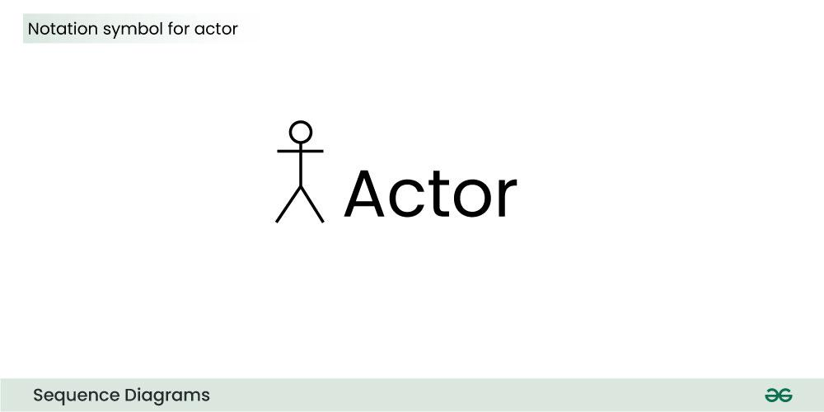
We use actors to depict various roles including human users and other external subjects. We represent an actor in a UML diagram using a stick person notation. We can have multiple actors in a sequence diagram.

For example:
Here the user in seat reservation system is shown as an actor where it exists outside the system and is not a part of the system.
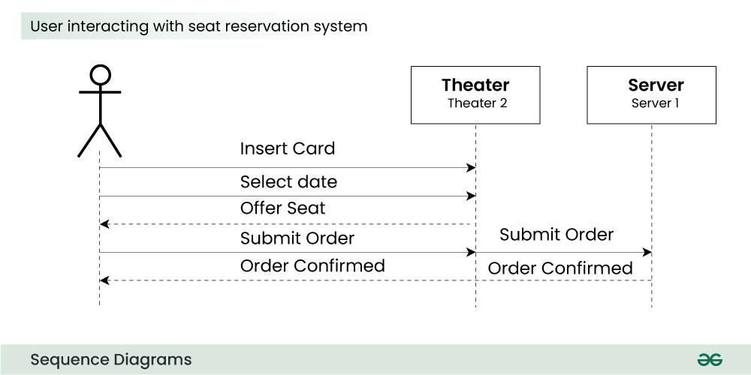

2. Lifelines
A lifeline is a named element which depicts an individual participant in a sequence diagram. So basically each instance in a sequence diagram is represented by a lifeline. Lifeline elements are located at the top in a sequence diagram. The standard in UML for naming a lifeline follows the following format:
Instance Name : Class Name
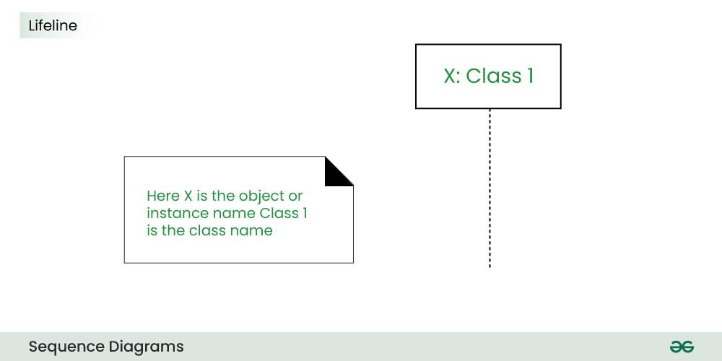
We display a lifeline in a rectangle called head with its name and type. The head is located on top of a vertical dashed line (referred to as the stem) as shown above.
- If we want to model an unnamed instance, we follow the same pattern except now the portion of lifeline’s name is left blank.
- Difference between a lifeline and an actor
  - A lifeline always portrays an object internal to the system whereas actors are used to depict objects external to the system.

3. Messages
Communication between objects is depicted using messages. The messages appear in a sequential order on the lifeline.
- We represent messages using arrows.
- Lifelines and messages form the core of a sequence diagram.
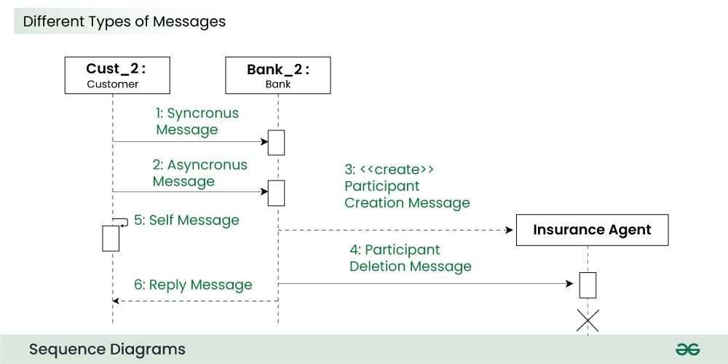
Messages can be broadly classified into the following categories:

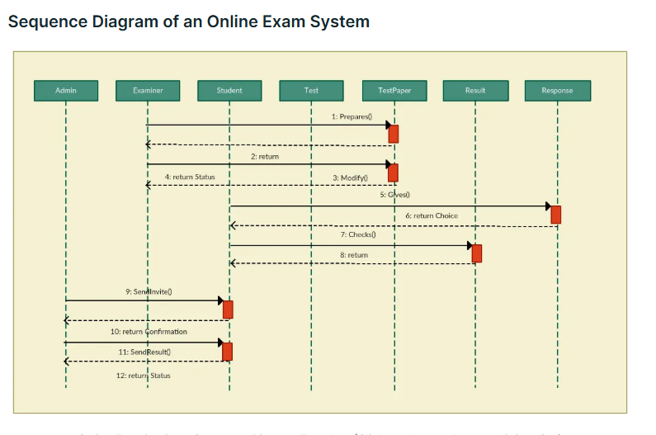

Sequence Diagram Example of an Online Movie Ticket Booking System

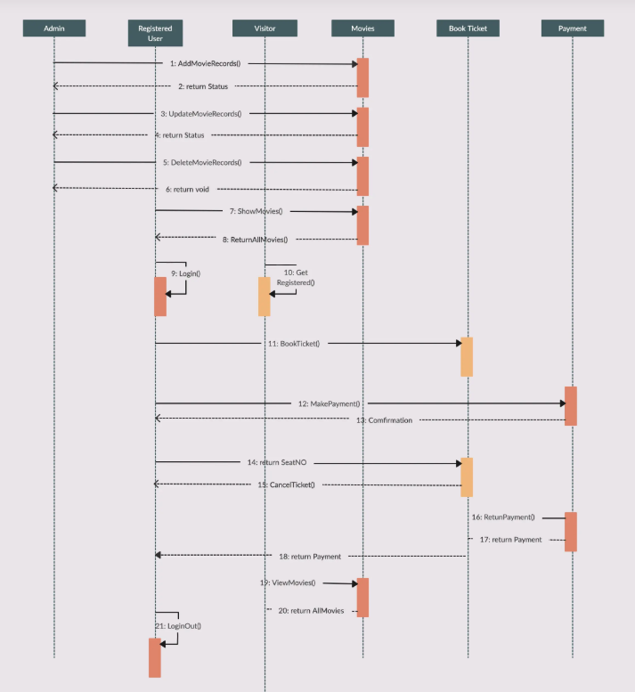
Sequence for Library management

